Choose the Right Hardware

Proposal Template

# Scenario 1: Manufacturing

Client Requirements and Potential Hardware Solution

Look through the scenario and find any relevant client requirements. Then, suggest a potential hardware type and explain how this hardware would satisfy each of the requirements.

|  |  |  |
| --- | --- | --- |
| **Which hardware might be most appropriate for this scenario?**  **(CPU / IGPU / VPU / FPGA)** | | |
| *VPU* | | |

|  |  |  |
| --- | --- | --- |
| **Requirement Observed**  **(Include at least two.)** | **How does the chosen hardware meet this requirement?** | |
| *Example requirement:*  The client requires a tiny device to be connected to their CPU—and their budget is only about $100 for each device. | *Example explanation:*  VPU or NCS2 is only about 27.40 mm in size and would fit in the price range. | |
| run inference on the video stream very quickly | *VPU* | |
| 5-10 years of lifetime | *FPGA* | |
| *Process 5 frames per second* | *VPU* | |

## Queue Monitoring Requirements

|  |  |  |
| --- | --- | --- |
| **Maximum number of people in the queue** | *10* | |
| **Model precision chosen (FP32, FP16, or Int8)** | *FP16* | |

## Test Results

After you've tested your application on all four hardware types (CPU, IGPU, VPU, and FPGA), copy the matplotlib output showing the comparison into the spaces below. You should have three graphs (for model load time, inference time, and FPS).

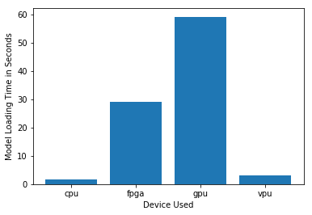

***Model Load Time***

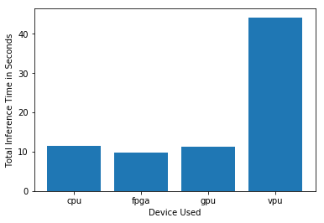

***Inference Time***

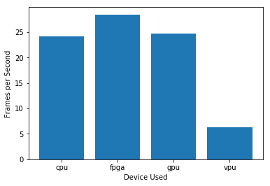

***FPS***

## Final Hardware Recommendation

Now synthesize your points from above and provide a brief write-up describing why the chosen hardware is the best choice for this scenario. Be sure to discuss the client's requirements, the test results, and how these relate to one another (e.g., perhaps one of the devices performed better than the rest, but does not meet one of the client's requirements).

|  |  |  |
| --- | --- | --- |
| **Write-up: Final Hardware Recommendation** | | |
| *VPU* | | |

# 

# Scenario 2: Retail

Client Requirements and Potential Hardware Solution

Look through the scenario and find any relevant client requirements. Then, suggest a potential hardware type and explain how this hardware would satisfy each of the requirements.

|  |  |  |
| --- | --- | --- |
| **Which hardware might be most appropriate for this scenario?**  **(CPU / IGPU / VPU / FPGA)** | | |
| *IGPU* | | |

|  |  |  |
| --- | --- | --- |
| **Requirement Observed**  **(Include at least two.)** | **How does the chosen hardware meet this requirement?** | |
| *Example requirement:*  The client requires a tiny device to be connected to their CPU—and their budget is only about $100 for each device. | *Example explanation:*  VPU or NCS2 is only about 27.40 mm in size and would fit in the price range. | |
| *Inference time need nto be real fast* | *IGPU/CPU* | |
| Already has an Intel i7 core processor | *IGPU* | |
| Mr. Lin does not have much money to invest in additional hardware. | *IGPU* | |

## Queue Monitoring Requirements

|  |  |  |
| --- | --- | --- |
| **Maximum number of people in the queue** | *5* | |
| **Model precision chosen (FP32, FP16, or Int8)** | *FP16* | |

## Test Results

After you've tested your application on all four hardware types (CPU, IGPU, VPU, and FPGA), copy the matplotlib output showing the comparison into the spaces below. You should have three graphs (for model load time, inference time, and FPS).

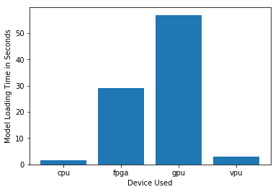

***Model Load Time***

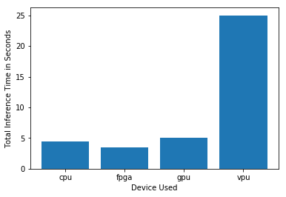

***Inference Time***

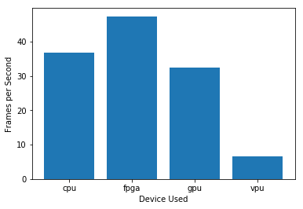

***FPS***

## Final Hardware Recommendation

Now synthesize your points from above and provide a brief write-up describing why the chosen hardware is the best choice for this scenario. Be sure to discuss the client's requirements, the test results, and how these relate to one another (e.g., perhaps one of the devices performed better than the rest, but does not meet one of the client's requirements).

|  |  |  |
| --- | --- | --- |
| **Write-up: Final Hardware Recommendation** | | |
| *IGPU* | | |

# 

# Scenario 3: Transportation

Client Requirements and Potential Hardware Solution

Look through the scenario and find any relevant client requirements. Then, suggest a potential hardware type and explain how this hardware would satisfy each of the requirements.

|  |  |  |
| --- | --- | --- |
| **Which hardware might be most appropriate for this scenario?**  **(CPU / IGPU / VPU / FPGA)** | | |
| *FPGA* | | |

|  |  |  |
| --- | --- | --- |
| **Requirement Observed**  **(Include at least two.)** | **How does the chosen hardware meet this requirement?** | |
| *Example requirement:*  The client requires a tiny device to be connected to their CPU—and their budget is only about $100 for each device. | *Example explanation:*  VPU or NCS2 is only about 27.40 mm in size and would fit in the price range. | |
| 7 CCTV cameras on the platform | *FPGA* | |
| *Budget is ok* | *FPGA* | |
| *future power requirements* | *CPU* | |

## Queue Monitoring Requirements

|  |  |  |
| --- | --- | --- |
| **Maximum number of people in the queue** | *15* | |
| **Model precision chosen (FP32, FP16, or Int8)** | *FP32* | |

## Test Results

After you've tested your application on all four hardware types (CPU, IGPU, VPU, and FPGA), copy the matplotlib output showing the comparison into the spaces below. You should have three graphs (for model load time, inference time, and FPS).

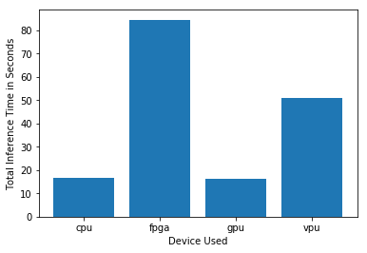

***Model Load Time***

**

***Inference Time***

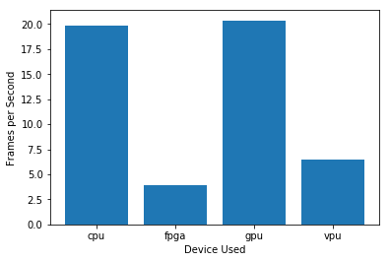

***FPS***

## Final Hardware Recommendation

Now synthesize your points from above and provide a brief write-up describing why the chosen hardware is the best choice for this scenario. Be sure to discuss the client's requirements, the test results, and how these relate to one another (e.g., perhaps one of the devices performed better than the rest, but does not meet one of the client's requirements).

|  |  |  |
| --- | --- | --- |
| **Write-up: Final Hardware Recommendation** | | |
| *FPGA* | | |

# 